**Volunteer Information Sheet: Auditory Target Detection**

**What is this study about?**

The present study aims at investigating humans’ ability to detect short auditory targets (i.e. “tones”) embodied in noise while they are perceiving contemporary –but unrelated- visual information. The main question we want to address is whether different inputs conveyed at the same time in distinct sensory modalities influence each other, and impact behavioral outcomes relying on the successful processing of one of them.

**What will I be asked to do?**

The study is split into two tasks with a first purely auditory task, and a second one where sounds and videos are presented at the same time. The goal is the same between the two tasks: You will have to detect auditory tone targets among a continuous noise as fast and accurately as possible by pressing a response key every time you think you detected one during the trial.

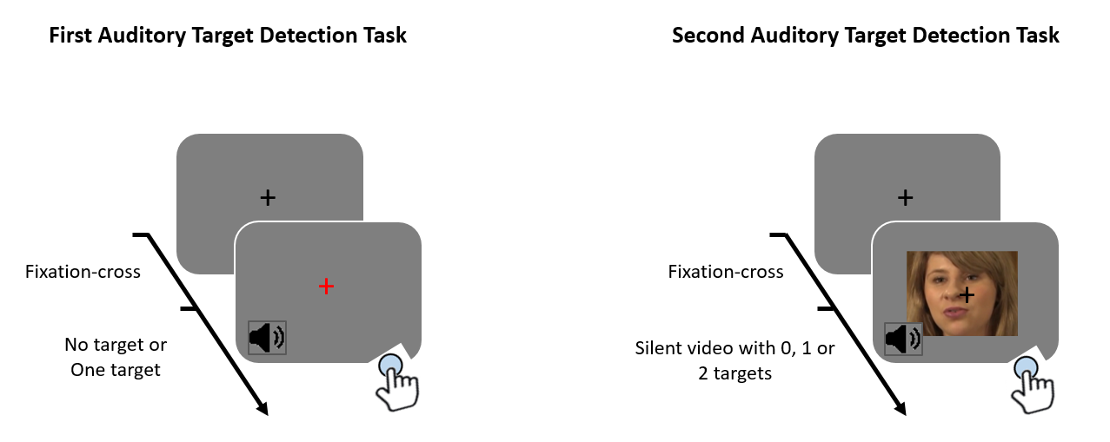

1) First Auditory Target Detection Task:

In the first task (left figure), every trial is preceded by a central black fixation-cross to get you ready. Then, the cross turns to red when the trial starts. During the entire red cross presentation (2 seconds), you will hear a noise sounding like when there is a snow screen on TV. Sometimes, there will be a target tone hidden in the noise (like a simple “bip”) and you will have to **press “1” key** as soon as you detect it. In some trials, there will be a tone target and in others no, so if you do not detect any tone, simply do not press the response key. There can be a maximum of one target tone per trial if present.

2) Second Auditory Target Detection Task:

In the second task (right figure), the task is exactly the same. You will have to **press “1” key** as fast and accurately as possible any time you here an auditory tone among the noise during the trial. The only difference is that during the noise presentation, there will be a silent video of a speaker’s face displayed in the centre of the screen. Additionally, there will be either **0**, **1** or **2** tones per trial, meaning that you will have to press 0, 1 or 2 times maximum during the same trial.

Importantly: gaze at the central fixation cross during the two tasks and keep your eyes open (blink naturally and attend every stimuli as if you were watching a normal movie).

**What are the risks?**

There are no risks to your physical or psychological wellbeing as a result of taking part in this study. In total, the whole experiment (i.e. to achieve the two tasks) will last around 45 minutes. If it proves too tiring, let the researcher know and you can have a good break or he will end the study.

**What are the benefits?**

The immediate impact of the findings from this study will be that our understanding of the function of audio and visual neural processing will be furthered. Additionally, these results will be published in an academic journal to inform the scientific community of our findings.

**What if I do not wish to continue at any stage or withdraw at a later date?**

You are free to withdraw from the study at any time. You do not have to give a reason. You may decline to answer any question or complete any task the experimenter asks of you. If you wish to withdraw at a later date, please contact either Emmanuel Biau (e.biau@bham.ac.uk)

**What happens to the information?**

The data will be stored confidentially by the researcher (Emmanuel Biau). You will be given a participant code and will not be identifiable by any of the data collected. We will not be able to provide individual results, but if you are interested in the results of the group as a whole, please let the researcher know and after all the data has been collected we will let you know of our findings.

**Experimenter Primary Investigator**

Dr. Emmanuel Biau Dr. Simon Hanslmayr

e.biau@bham.ac.uk s.hanslmayr@bham.ac.uk